# **Hands-on Activity 1.1: Using Pseudo-code Statements and Flowchart Symbols**

Calvin Earl L. Planta 8/21/24 CPE21S4

**Flowchart**

1. Problem 1 (Infinite Algorithm)

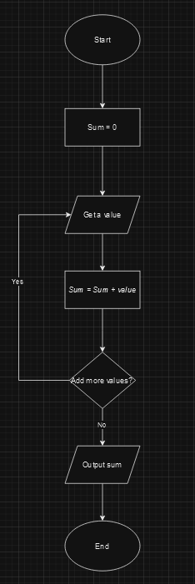

1. Problem 2 (Finite Algorithm)

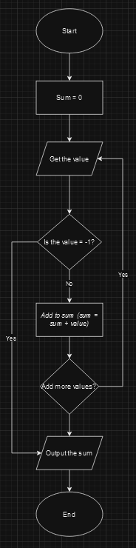

1. Design an algorithm and the corresponding flowchart for finding the sum of the numbers 2, 4, 6, 8, …, n (output: Algorithm and Flowchart)

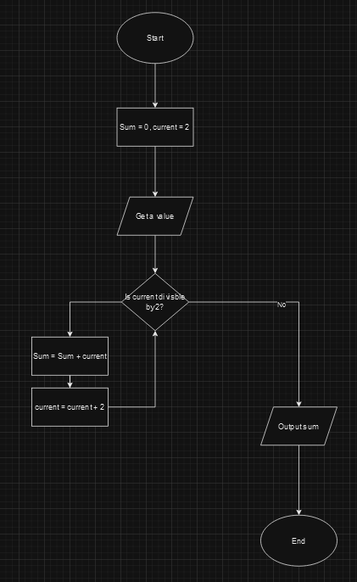

**Pseudo-Code**

1. Design an algorithm and the corresponding flowchart for finding the sum of the numbers 2, 4, 6, 8, …, n (output: Algorithm and Flowchart)

Start

Set sum to 0

Current number to 2

While current number =< n

Add current number to sum

Increment current number by 2

Display value

End

1. Write an algorithm to read 100 numbers and then display the sum.

Start

Set sum to 0

Set counter to 1

While counter =< 100

Read the next number and store it in num.

Add num to sum.

Increment counter by 1.

Display sum.

End

1. Write an algorithm to read two numbers then display the largest.

Start

Read the first number and store it to num1

Reed the second number and store it to num2

If num1 > num2

Set num1 as the largest number

Else set num2 as the largest number

Display the largest number

End

1. Write an algorithm to read two numbers then display the Smallest.

Start

Read the first number and store it to num1

Reed the second number and store it to num2

If num1 < num2

Set num1 as the smallest number

Else set num2 as the smallest number

Display the smallest number

End

1. Write an algorithm to read three numbers then display the largest.

Start

Read the first number and store it to num1

Reed the second number and store it to num2

Read the third number and store it to num3

If num1 > num2 and num1 > num3

Set largest to num1.

Else if num2 > num1 and num2 > num3

Set largest to num2.

Else set largest to num3.

Display largest.

End

1. Write an algorithm to read 100 numbers then display the largest.

Start

Set largest to a very small number (or the first number read) and counter to 1.

While counter ≤ 100

Read the next number and store it in num.

If num > largest

Set largest to num.

Increment counter by 1.

Display largest.

End